Q.1 Define the term computer architecture in detail?
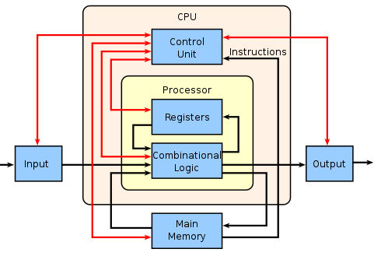
In computer engineering, computer architecture is a set of rules and methods that describe the functionality, organization, and implementation of computer systems. The architecture of a system refers to its structure in terms of separately specified components of that system and their interrelationships.^{[1]}
Some definitions of architecture define it as describing the capabilities and programming model of a computer but not a particular implementation.^{[2]} In other definitions computer architecture involves instruction set architecture design, microarchitecture design, logic design, and implementation.^{[3]}
The discipline of computer architecture has three main subcategories:^{[14]}
- Instruction set architecture (ISA): defines the machine code that a processor reads and acts upon as well as the word size, memory address modes, processor registers, and data type.
- Microarchitecture: also known as "computer organization", this describes how a particular processor will implement the ISA.^{[15]} The size of a computer's CPU cache for instance, is an issue that generally has nothing to do with the ISA.
- Systems design: includes all of the other hardware components within a computing system, such as data processing other than the CPU (e.g., direct memory access), virtualization, and multiprocessing.

Definition
Computer architecture is concerned with balancing the performance, efficiency, cost, and reliability of a computer system. The case of instruction set architecture can be used to illustrate the balance of these competing factors. More complex instruction sets enable programmers to write more space efficient programs, since a single instruction can encode some higher-level abstraction (such as the x86 Loop instruction).

Q.2 DRAW AND EXPLAIN THE BASIC FUNCTIONAL UNITS OF COMPUTER

Functional Unit of Computer
The functional units of a computer i.e. input unit, arithmetic and logic unit, memory, control unit, output unit all are connected with the interconnection network that helps them in exchanging the information as you can see in the image below. Now, let us explore each functional unit separately.

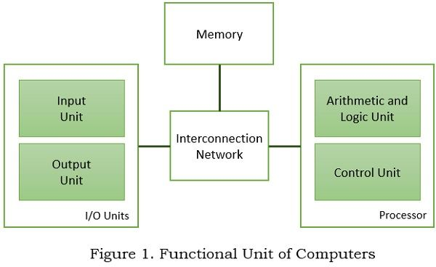

Input Unit
The input to the computer is either a data or instruction, that guides the arithmetic and logic unit about what operations have to be performed and also controls the movement of data between the computer and its I/O devices.

Memory Unit
A memory unit is required to store the programs that have the set of instructions that instructs Arithmetic and logic unit which operation has to be performed. It also stores the data associated with the program. The memory can further be classified into three types:
- Primary Memory
Primary memory is also known as the main memory or the random-access memory (RAM). It is the fastest accessible memory of the computer.
- Secondary Memory
Secondary memory is the hard disk of your system, it also includes flash drive, optical disks, magnetic disk. The secondary memory is slower and less expensive as compared to primary memory.
- Cache Memory
Cache memory can be accessed much faster as compared to primary memory and it is even smaller in size. It is stored with the data that is required frequently by the processor.

Arithmetic Logic Unit
All the arithmetic operations are performed by the arithmetic logic unit of the processors. Arithmetic operations such as addition, subtraction, division, multiplication, comparison between the numbers, etc.

Output Unit
A computer is a functional unit and as it has an input unit to accept the input it also has the output unit to provide the generated output by the system. The most familiar device used to output a result is a printer.

Control Unit
The functions of input, ALU, memory, and output unit must be coordinated so that everything goes in sequence i.e. the processor accepts input, place it in memory, processes the stored input, and generates output. This entire sequence is coordinate by the control unit.

Q.3 WHAT IS BUS EXPLAIN IN DETAIL
A bus is a subsystem that is used to connect computer components and transfer data between them. For example, an internal bus connects computer internals to the motherboard. A “bus topology” or design can also be used in other ways to describe digital connections.
A bus may be parallel or serial. Parallel buses transmit data across multiple wires. Serial buses transmit data in bit-serial format.
A bus was originally an electrical parallel structure with conductors connected with identical or similar CPU pins, such as a 32-bit bus with 32 wires and 32 pins. The earliest buses, often termed electrical power buses or bus bars, were wire collections that connected peripheral devices and memory, with one bus designated for peripheral devices and another bus for memory. Each bus included separate instructions and distinct protocols and timing.
Parallel bus standards include advanced technology attachment (ATA) or small computer system interface (SCSI) for printer or hard drive devices. Serial bus standards include universal serial bus (USB), FireWire or serial ATA with a daisy-chain topology or hub design for devices, keyboards or modem devices.
Computer bus types are as follows:
- System Bus: A parallel bus that simultaneously transfers data in 8-, 16-, or 32-bit channels and is the primary pathway between the CPU and memory.
- Internal Bus: The internal bus, also known as internal data bus, memory bus, system bus or front-side bus, connects all the internal components of a computer, such as CPU and memory, to the motherboard. Internal data buses are also referred to as local buses, because they are intended to connect to local devices. This bus is typically rather quick and is independent of the rest of the computer operations.
- External Bus: Connects peripheral devices to the motherboard, such as scanners or disk drives.
- Expansion Bus: Allows expansion boards to access the CPU and RAM.
- Frontside Bus: Main computer bus that determines data transfer rate speed and is the primary data transfer path between the CPU, RAM and other motherboard devices.
- Backside Bus: Transfers secondary cache (L2 cache) data at faster speeds, allowing more efficient CPU operations.

Memory bus
The memory bus is the bus which connects the main memory to the memory controller in computer systems. Originally, general-purpose buses like VMEbus and the S-100 bus were used, but to reduce latency, modern memory buses are designed to connect directly to DRAM chips, and thus are designed by chip standards bodies such as JEDEC.

Q.4 GIVE THE DIFFRENCE BETWEEN COMPUTER ARCHITECTURE AND ORHANIZATION
Computer Architecture | Computer Organization
Computer Architecture is concerned with the way hardware components are connected together to form a computer system. | Computer Organization is concerned with the structure and behaviour of a computer system as seen by the user.
It acts as the interface between hardware and software. | It deals with the components of a connection in a system.
Computer Architecture helps us to understand the functionalities of a system. | Computer Organization tells us how exactly all the units in the system are arranged and interconnected.
A programmer can view architecture in terms of instructions, addressing modes and registers. | Whereas Organization expresses the realization of architecture.
While designing a computer system architecture is considered first. | An organization is done on the basis of architecture.
Computer Architecture deals with high-level design issues. | Computer Organization deals with low-level design issues.
Architecture involves Logic (Instruction sets, Addressing modes, Data types, Cache optimization) | Organization involves Physical Components (Circuit design, Adders, Signals, Peripherals)

Q.5. Explain multiple bus organization in detail.
A bus is an important memory transferring device used by most computer devices and Smartphones to pass data back and forth across the entire system. The overall speed of the machine is directly affected by the types of buses used by it. Simple computer design uses single bus structures for transferring data, and Multiple bus organization uses multiple buses for enhanced performance.
In a multi-bus architecture, all the pathways are suited for handling some special types of information.
In single bus architecture, all the devices use a common bus for data transfer; thus, the system’s efficiency and performance is lower. However, in the multiple bus organization, the wasted time lowers down, and thus the speed and performance of the entire system boost up. Thus, this is one of the key reasons behind using Multiple bus organization.
Additionally, the Multiple Bus organization also provides many choices for connecting the devices to the computer, making it more compatible.
Multiple bus organization is primarily used in industrial systems. In this structure, various devices that have different transfer rates can be connected. At the same time, maximum throughput is maintained. Some benefits of multiple bus architecture are:
* Allows more number of devices to be connected to the computer
* Faster execution because many devices can work simultaneously resulting in performance enhancement* Compatible with both old and new devices alike* Multi-core processor that transfers more information and minimizes the wait time

Multiple Bus Organization Improves Efficiency

Additional Buses Allow Expansion

More Buses Means More Compatibility

Multi-Core Requires Multiple Buses

Q.6.Explain CPU structure with neat diagram.

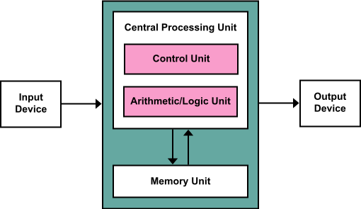

A Central Processing Unit is also called a processor, central processor, or microprocessor. It carries out all the important functions of a computer. It receives instructions from both the hardware and active software and produces output accordingly. It stores all important programs like operating systems and application software. CPU also helps Input and output devices to communicate with each other. Owing to these features of CPU, it is often referred to as the brain of the computer.
CPU is installed or inserted into a CPU socket located on the motherboard. Furthermore, it is provided with a heat sink to absorb and dissipate heat to keep the CPU cool and functioning smoothly.
Generally, a CPU has three components:
- ALU (Arithmetic Logic Unit)
- Control Unit
- Memory or Storage Unit
- Control Unit: It is the circuitry in the control unit, which makes use of electrical signals to instruct the computer system for executing already stored instructions. It takes instructions from memory and then decodes and executes these instructions.
- ALU: It is the arithmetic logic unit, which performs arithmetic and logical functions. Arithmetic functions include addition, subtraction, multiplication division, and comparisons. Logical functions mainly include selecting, comparing, and merging the data.
- Memory or Storage Unit/ Registers: It is called Random access memory (RAM). It temporarily stores data, programs, and intermediate and final results of processing. So, it acts as a temporary storage area that holds the data temporarily, which is used to run the computer.

Types of CPU:
CPUs are mostly manufactured by Intel and AMD, each of which manufactures its own types of CPUs. In modern times, there are lots of CPU types in the market. Some of the basic types of CPUs are described below:
Single Core CPU: Single Core is the oldest type of computer CPU, which was used in the 1970s. It has only one core to process different operations. It can start only one operation at a time; the CPU switches back and forth between different sets of data streams when more than one program runs.
Dual Core CPU: As the name suggests, Dual Core CPU contains two cores in a single Integrated Circuit (IC). Although each core has its own controller and cache, they are linked together to work as a single unit and thus can perform faster than the single-core processors.
Quad Core CPU: This type of CPU comes with two dual-core processors in one integrated circuit (IC) or chip. So, a quad-core processor is a chip that contains four independent units called cores.

Q.7.Explain CPU functions in details.
The central processing unit (CPU) is the primary component of any digital computer system, consisting of the main memory, the control unit, and the arithmetic-logic unit. It is the physical heart of the entire computer system,
A microprocessor is a small electronic device that contains the arithmetic, logic, and control circuitry required to perform the functions of a digital computer’s central processing unit. In practice, this type of integrated circuit is capable of interpreting and executing program instructions in addition to performing arithmetic operations.

The Central Processing Unit (CPU) has the following characteristics:
- The CPU is regarded as the computer’s brain.
- The CPU is responsible for all data processing operations.
- It saves information such as data, intermediate results, and instructions (program).
- It directs the operation of all computer components.
The CPU itself is made up of the three components listed below.
- Memory or Storage Unit
- Control Unit
- Arithmetic Logic Unit

Memory or Storage Unit
The memory unit’s functions are as follows:
- It saves all of the data and instructions needed for processing.
- It saves intermediate processing results.
- It saves the final results of processing before they are sent to an output device.
- The main memory is where all inputs and outputs are routed.
The Control Unit
This unit manages the operations of all computer components but does not perform any actual data processing. To function properly, all CPU components must be synchronized. The control unit performs this function at a rate determined by the clock speed and is in charge of directing the operations of the other units through the use of timing signals that run throughout the CPU.
This unit’s functions are as follows:
- It is in charge of controlling the transfer of data and instructions among the various components of a computer.
- It manages and coordinates all of the computer’s units.
- It reads instructions from memory, interprets them, and directs the computer’s operation.
- It communicates with Input/Output devices to transfer data.
- It neither processes nor stores data.

Q.8. What is Bus? Draw the single bus structure.

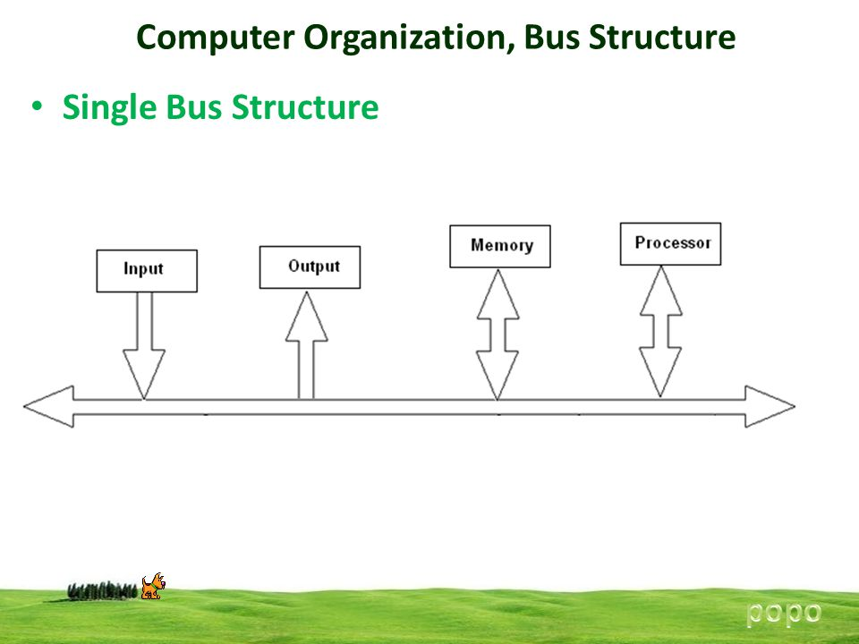

A bus is a high-speed internal connection. Buses are used to send control signals and data between the processor and other components.
Three types of bus are used.
- Address bus - carries memory addresses from the processor to other components such as primary storage and input/output devices. The address bus is unidirectional.
- Data bus - carries the data between the processor and other components. The data bus is bidirectional.
- Control bus - carries control signals from the processor to other components. The control bus also carries the clock's pulses. The control bus is unidirectional.
Types of Buses in Computer Architecture Computers comprises of many internal components and in order for these components to communicate with each other, a ‘bus’ is used for that purpose. A bus is a common pathway through which information flows from one component to another. This pathway is used for communication purpose and can be established between two or more computer components. We are going to review different computer bus architectures that are used in computers.
Functions of Buses in Computers
The functions of buses can be summarized as below:
I. Data sharing - All types of buses found on a computer must be able to transfer data
between the computer peripherals connected to it.The data is transferred in in either serial or parallel, which allows the exchange of 1, 2,4 or even 8 bytes of data at a time. (A byte is a group of 8 bits). Buses are classifieddepending on how many bits they can move at the same time, which means that we have 8-bit, 16-bit, 32-bit or even 64-bit buses.
2. Addressing - A bus has address lines, which match those of the processor. This allows data to be sent to or from specific memory locations.
3. Power - A bus supplies power to various peripherals that are connected to it.
4. Timing - The bus provides a system clock signal to synchronize the peripherals attached to it with the rest of the system.

Q.9. What are the advantages of multiple bus organization over a single bus organization.
All computing devices, from smartphones to supercomputers, pass data back and forth along electronic channels called "buses." You can think about the buses like freeways, in that having additional buses makes it easier to quickly transfer data, in the same way having more freeways or additional lanes increases the speed of traffic.

Multiple Bus Organization Improves Efficiency
In a single-bus architecture, all components including the central processing unit, memory and peripherals share a common bus. When many devices need the bus at the same time, this creates a state of conflict called bus contention; some wait for the bus while another has control of it.

Additional Buses Allow Expansion
Having multiple buses available gives you more choices for connecting devices to your computer, as hardware makers may offer the same component for more than one bus type. As Digital Trends points out, most desktop PCs use the Serial Advanced Technology Attachment interface for internal hard drives, but many external hard drives and flash drives connect via USB.

More Buses Means More Compatibility
As with all of a computer's components, bus designs evolve, with new types being introduced every few years. For example, the PCI bus that supports video, network and other expansion cards predates the newer PCIe interface, and USB has undergone several major revisions.

Multi-Core Requires Multiple Buses
A single central processing unit places heavy demands on the bus that carries memory data and peripheral traffic for hard drives, networks and printers; since the mid-2000s, however, most computers have adopted a multi-core model that require additional buses.
a) The multi bus architecture offers high speed and efficiency. This is because in multi bus architecture, the processor shares a multiple number of buses.
b) This architecture offers a great expansion because a large number of connectives from the single computer system are passed to multiple processors to meet the goals of a program.
c) Offers a high compatibility since the processes can be run within the short period of time.

